Pentakis Dodecahedron

Definition
# Source: AI Source: Provided by: [Data Path: Persons Table -> ID Column: 1, Name_En Column: Motasem Essam] -> From: [ChatGPT] on [7/25/2026]
A Pentakis Dodecahedron is a convex Catalan solid consisting of 60 congruent isosceles triangular faces, 90 edges, and 32 vertices.
It is the dual polyhedron of the Truncated Icosahedron, the Archimedean solid commonly known as the soccer-ball shape.
It can also be constructed by attaching a pentagonal pyramid to each of the 12 faces of a regular dodecahedron. The resulting solid has 12 original dodecahedron vertices and 20 pyramid-apex vertices.
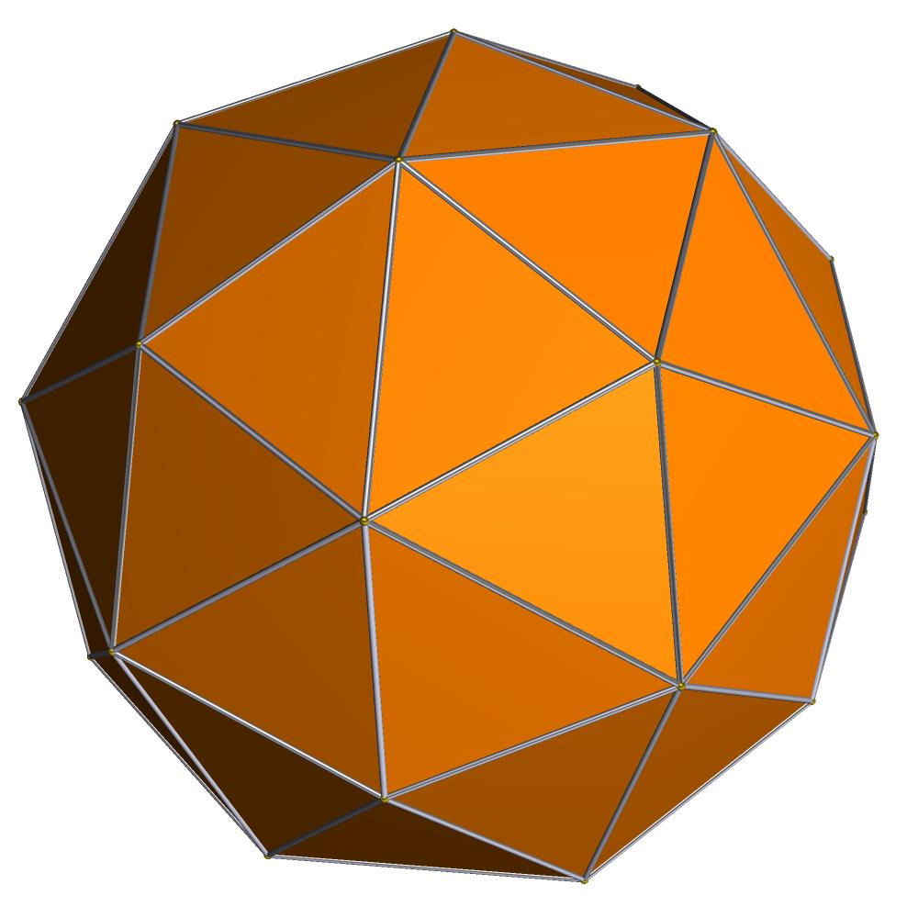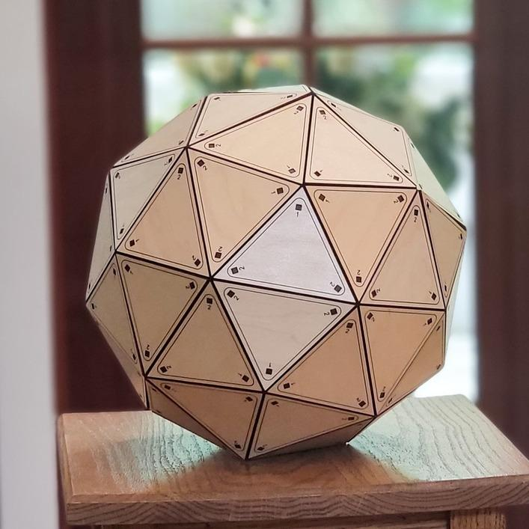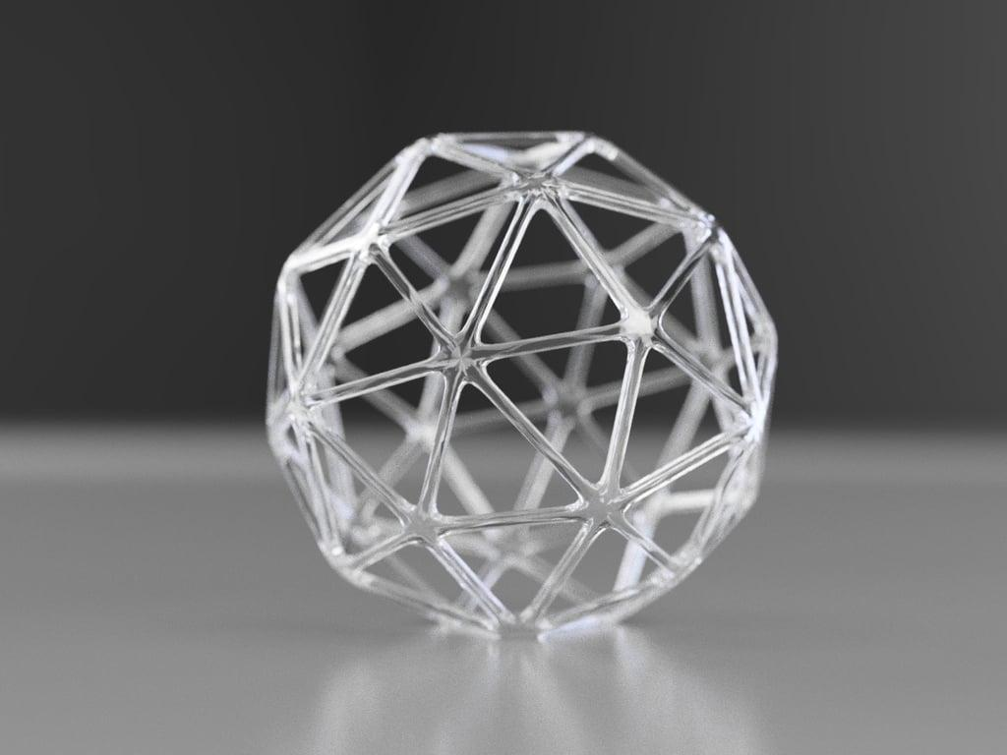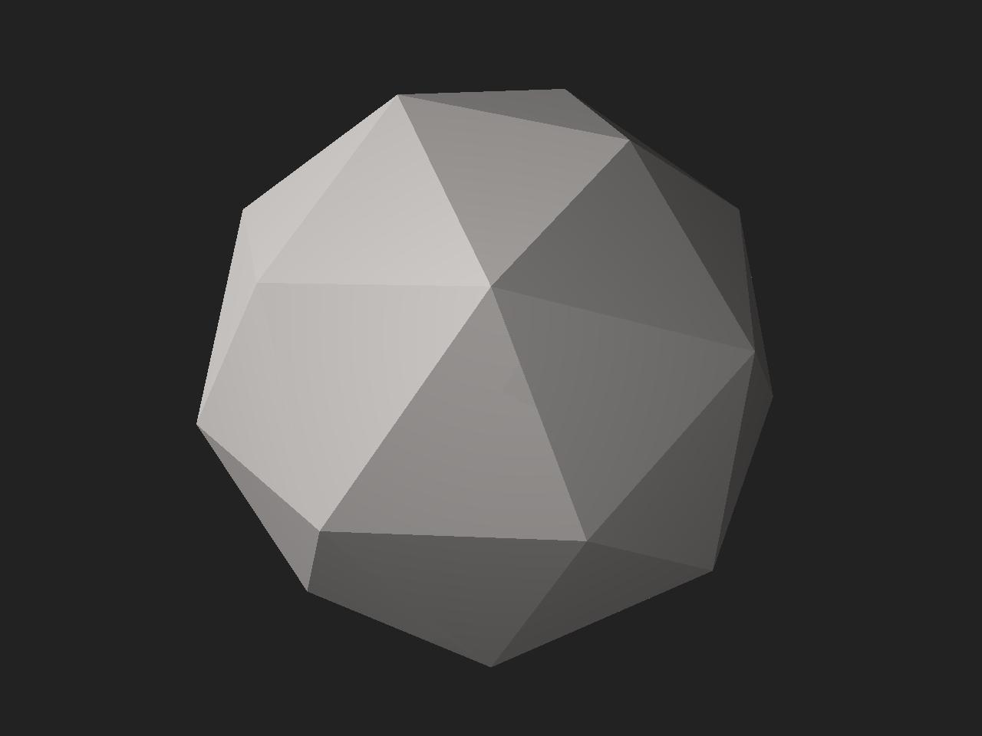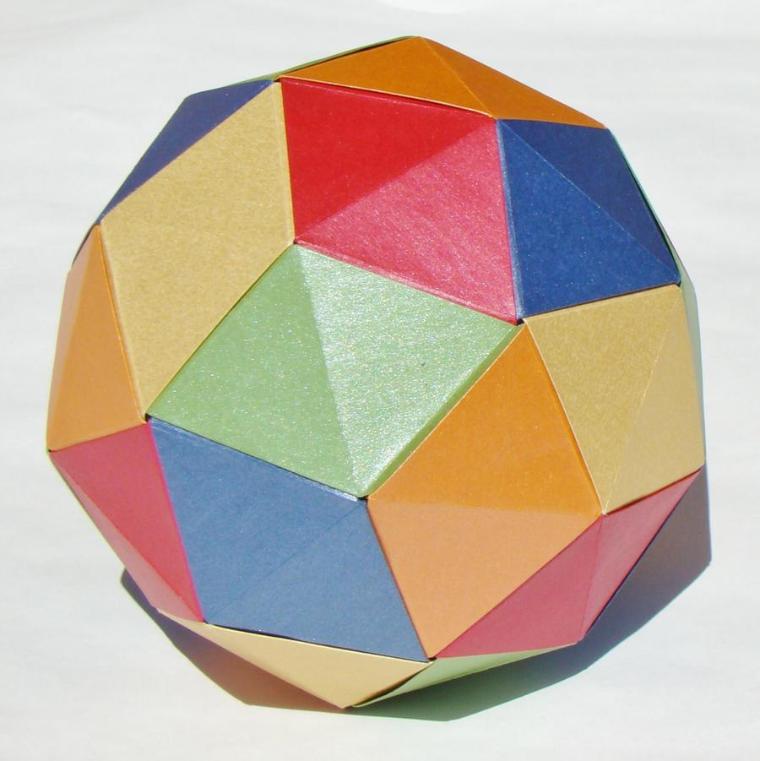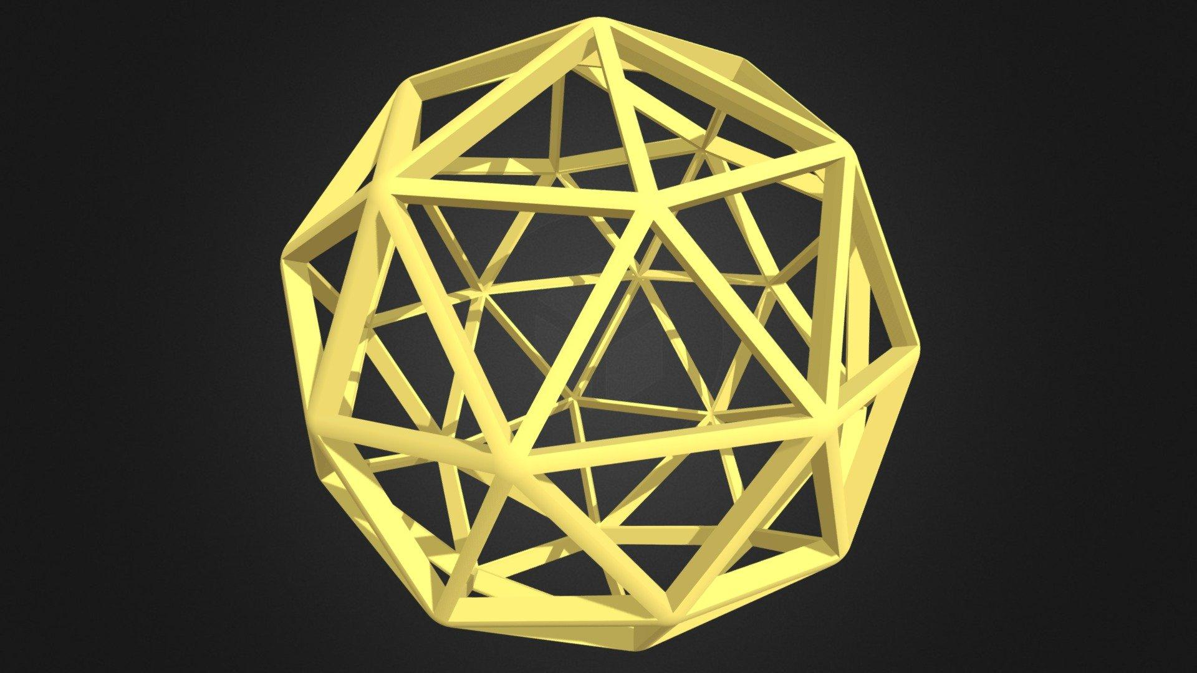

Simple Definition
# Source: AI Source: Provided by: [Data Path: Persons Table -> ID Column: 1, Name_En Column: Motasem Essam] -> From: [ChatGPT] on [7/25/2026]
The Pentakis Dodecahedron is a three-dimensional solid that looks like a dodecahedron covered with pointed triangular pyramids.
- It has 12 pentagonal pyramid-like sections.
- Each pentagonal section is divided into five triangular faces.
- It has 60 identical triangular faces in total.
- Its faces are all isosceles triangles.

Geometric Structure
# Source: AI Source: Provided by: [Data Path: Persons Table -> ID Column: 1, Name_En Column: Motasem Essam] -> From: [ChatGPT] on [7/25/2026]
The Pentakis Dodecahedron has the following structure:
- 60 faces: congruent isosceles triangles.
- 90 edges: two different edge lengths.
- 32 vertices: two different vertex configurations.
- 12 pentagonal regions: corresponding to the original dodecahedron faces.
- 20 additional vertices: corresponding to the pyramid tips.

Face Structure
# Source: AI Source: Provided by: [Data Path: Persons Table -> ID Column: 1, Name_En Column: Motasem Essam] -> From: [ChatGPT] on [7/25/2026]
The Pentakis Dodecahedron consists of 60 congruent isosceles triangular faces.
Each triangular face has:
- Two equal shorter sides.
- One longer side.
- Two equal acute angles.
- One obtuse angle.
For the standard Catalan form, the approximate interior angles are:
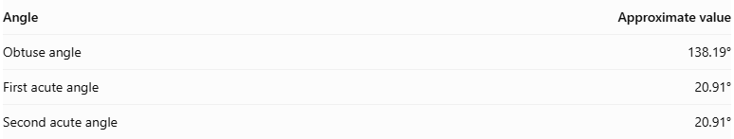
Angle | Approximate value
Obtuse angle | 138.19°
First acute angle | 20.91°
Second acute angle | 20.91°
The angles add up to 180°.
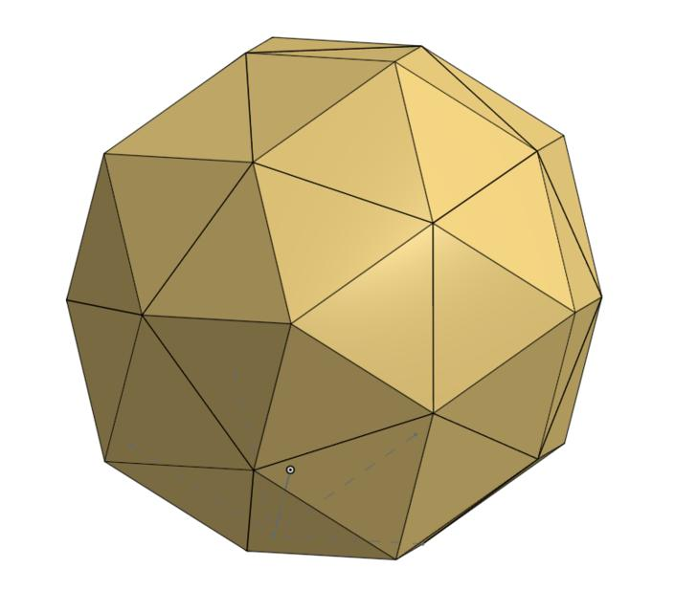

Edge Structure
# Source: AI Source: Provided by: [Data Path: Persons Table -> ID Column: 1, Name_En Column: Motasem Essam] -> From: [ChatGPT] on [7/25/2026]
The solid has 90 edges, divided into two groups:
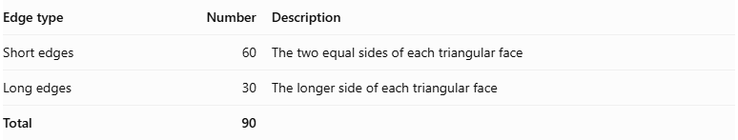
Edge type | Number | Description
Short edges | 60 | The two equal sides of each triangular face
Long edges | 30 | The longer side of each triangular face
Total | 90
The ratio of short edge length to long edge length is:
$$\frac{12+3φ}{19}≈0.887$$
where $φ$ is the golden ratio:
$$φ=\frac{1+\sqrt{5}}{2}$$

Vertex Structure
# Source: AI Source: Provided by: [Data Path: Persons Table -> ID Column: 1, Name_En Column: Motasem Essam] -> From: [ChatGPT] on [7/25/2026]
The Pentakis Dodecahedron has 32 vertices, divided into two groups:
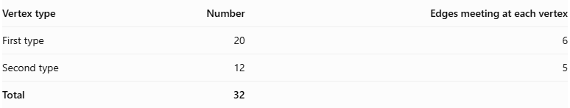
Vertex type | Number | Edges meeting at each vertex
First type | 20 | 6
Second type | 12 | 5
Total | 32
- 20 six-valence vertices: six edges meet at each vertex. These correspond to the vertices of an inscribed icosahedron.
- 12 five-valence vertices: five edges meet at each vertex. These correspond to the vertices of an inscribed dodecahedron.

Mathematical Properties
# Source: AI Source: Provided by: [Data Path: Persons Table -> ID Column: 1, Name_En Column: Motasem Essam] -> From: [ChatGPT] on [7/25/2026]
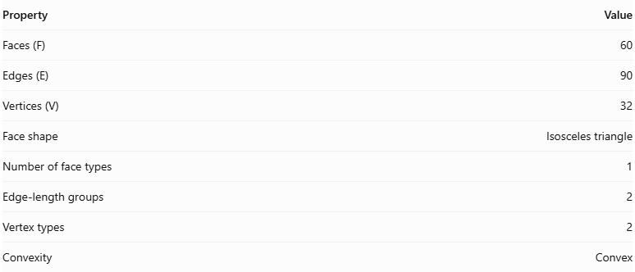
Property | Value
Faces (F) | 60
Edges (E) | 90
Vertices (V) | 32
Face shape | Isosceles triangle
Number of face types | 1
Edge-length groups | 2
Vertex types | 2
Convexity | Convex
Euler's formula
For a convex polyhedron:
$$V-E+F=2$$
Substituting the Pentakis Dodecahedron values:
$$32-90+60=2$$
Therefore, the Pentakis Dodecahedron satisfies Euler's polyhedron formula.
Face angles
Using the standard edge ratio, each triangular face has approximately:
- One angle of ${68.5}^{°}$.
- Two equal angles of ${55.75}^{°}$.
Their sum is ${180}^{°}$.

Symmetry
# Source: AI Source: Provided by: [Data Path: Persons Table -> ID Column: 1, Name_En Column: Motasem Essam] -> From: [ChatGPT] on [7/25/2026]
The Pentakis Dodecahedron has full icosahedral symmetry, denoted by:
$$I_{h}$$
Its symmetry includes:
- Fivefold rotational axes.
- Threefold rotational axes.
- Twofold rotational axes.
- Reflection symmetries.
- Inversion symmetry.
It shares the same symmetry group as the regular icosahedron and regular dodecahedron.

Surface Area and Volume
# Source: AI Source: Provided by: [Data Path: Persons Table -> ID Column: 1, Name_En Column: Motasem Essam] -> From: [ChatGPT] on [7/25/2026]
The surface area can be calculated by adding the areas of the 60 congruent triangular faces.
Let:
- $L$ = long edge length of each triangular face.
- $r=dfrac12+3φ19$ = short-to-long edge ratio.
The height of each triangular face is:
$$h=\sqrt{r^{2}L^{2}-\frac{L^{2}}{4}}$$
The total surface area is:
$$SA=60\left(\frac{1}{2}Lh\right)$$
Therefore:
$$\boxed{SA=30L^{2}\sqrt{r^{2}-\frac{1}{4}}}$$
The volume depends on the overall scale of the solid and can be calculated from its three-dimensional coordinates or its dual Truncated Icosahedron.

Relationship to Other Solids
# Source: AI Source: Provided by: [Data Path: Persons Table -> ID Column: 1, Name_En Column: Motasem Essam] -> From: [ChatGPT] on [7/25/2026]
The Pentakis Dodecahedron is the dual polyhedron of the Truncated Icosahedron.
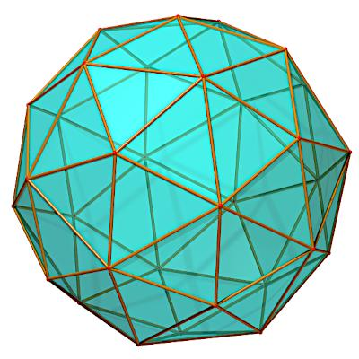
Pentakis Dodecahedron
- 60 faces
- 90 edges
- 32 vertices
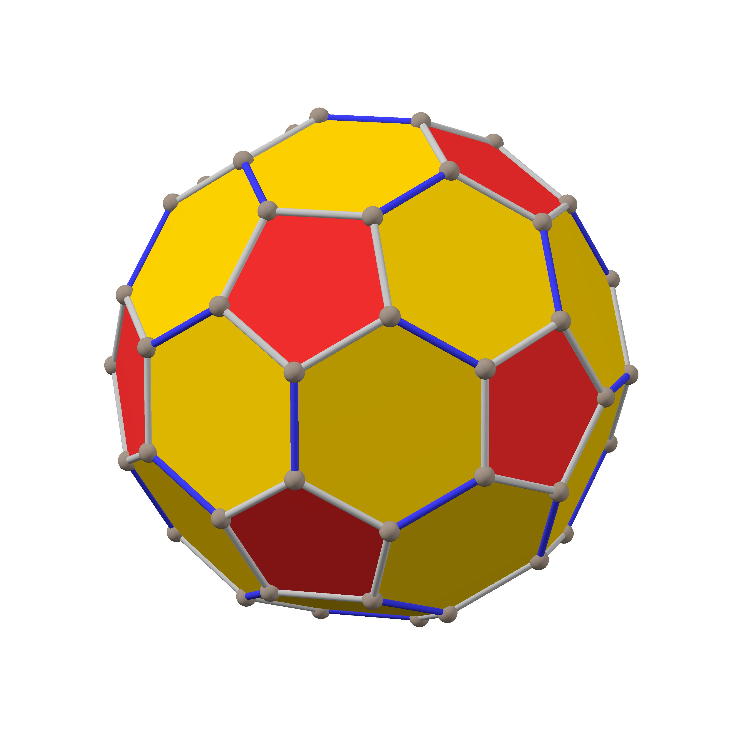
Truncated Icosahedron
- 32 faces
- 90 edges
- 60 vertices
The dual relationship means:
- Each face of the Pentakis Dodecahedron corresponds to a vertex of the Truncated Icosahedron.
- Each vertex corresponds to a face.
- Both solids have 90 edges.
The Truncated Icosahedron has 12 regular pentagonal faces and 20 regular hexagonal faces.

Constructing a Pentakis dodecahedron

Geometric Instruments Used
# Source: AI Source: Provided by: [Data Path: Persons Table -> ID Column: 1, Name_En Column: Motasem Essam] -> From: [ChatGPT] on [7/25/2026]
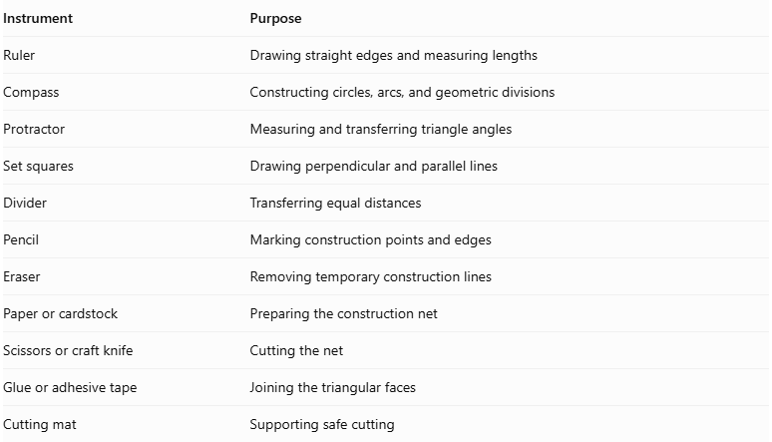
Instrument | Purpose
Ruler | Drawing straight edges and measuring lengths
Compass | Constructing circles, arcs, and geometric divisions
Protractor | Measuring and transferring triangle angles
Set squares | Drawing perpendicular and parallel lines
Divider | Transferring equal distances
Pencil | Marking construction points and edges
Eraser | Removing temporary construction lines
Paper or cardstock | Preparing the construction net
Scissors or craft knife | Cutting the net
Glue or adhesive tape | Joining the triangular faces
Cutting mat | Supporting safe cutting

Instrument-Based Construction Procedures
# Source: AI Source: Provided by: [Data Path: Persons Table -> ID Column: 1, Name_En Column: Motasem Essam] -> From: [ChatGPT] on [7/25/2026]
There are two principal practical approaches: constructing the solid from its triangular net, or augmenting a regular dodecahedron with pyramidal faces.

Method 1: Construction Using a Triangular Net
# Source: AI Source: Provided by: [Data Path: Persons Table -> ID Column: 1, Name_En Column: Motasem Essam] -> From: [ChatGPT] on [7/25/2026]
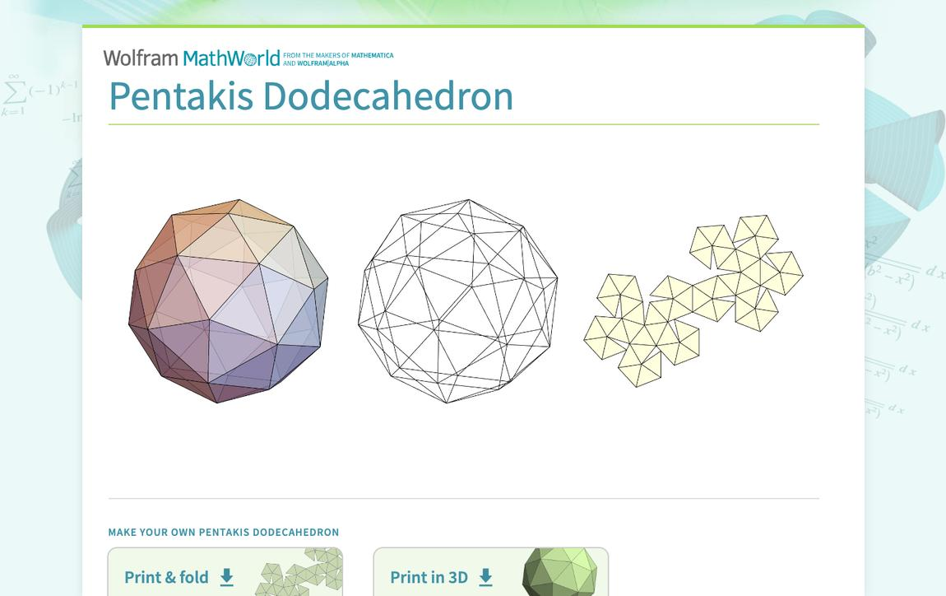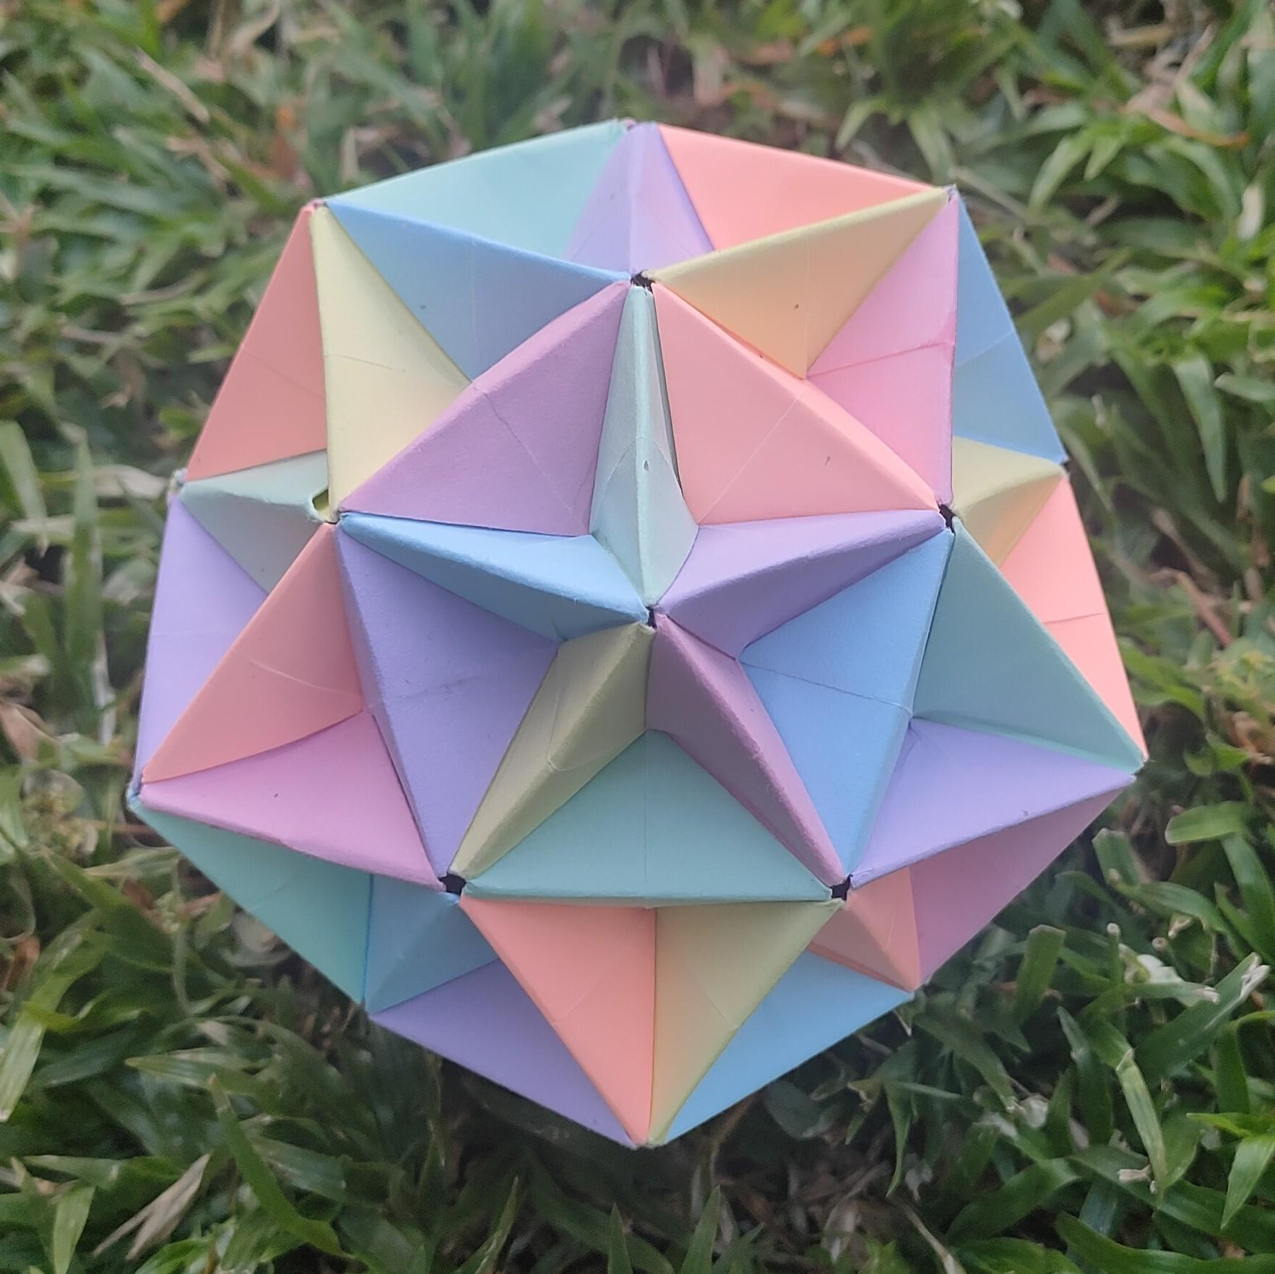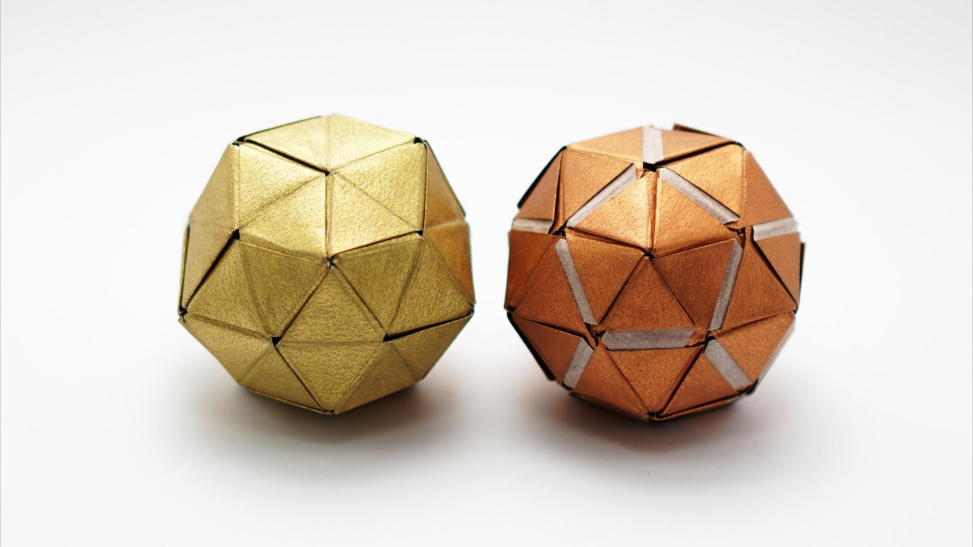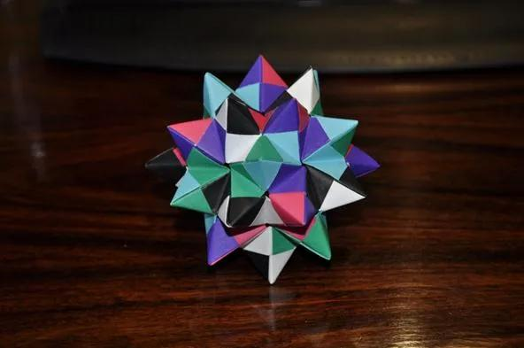
- Determine the face dimensions: Establish the short-edge and long-edge lengths using the standard Pentakis Dodecahedron proportions.
- Construct the triangular faces: Use a ruler, compass, and protractor to draw 60 congruent isosceles triangles.
- Arrange the net: Place the triangles in an arrangement that allows the complete polyhedron to fold together. Include joining tabs where necessary.
- Mark the folding edges: Draw light fold lines along the edges that will be joined.
- Cut out the net: Carefully cut around its external boundary.
- Fold the triangular faces: Fold along the marked edges to form the three-dimensional structure.
- Join the edges: Attach matching edges using glue or adhesive tape.
- Complete the solid: Check that all faces meet correctly and that the model closes without gaps.

Method 2: Construction by Augmenting a Regular Dodecahedron
# Source: AI Source: Provided by: [Data Path: Persons Table -> ID Column: 1, Name_En Column: Motasem Essam] -> From: [ChatGPT] on [7/25/2026]
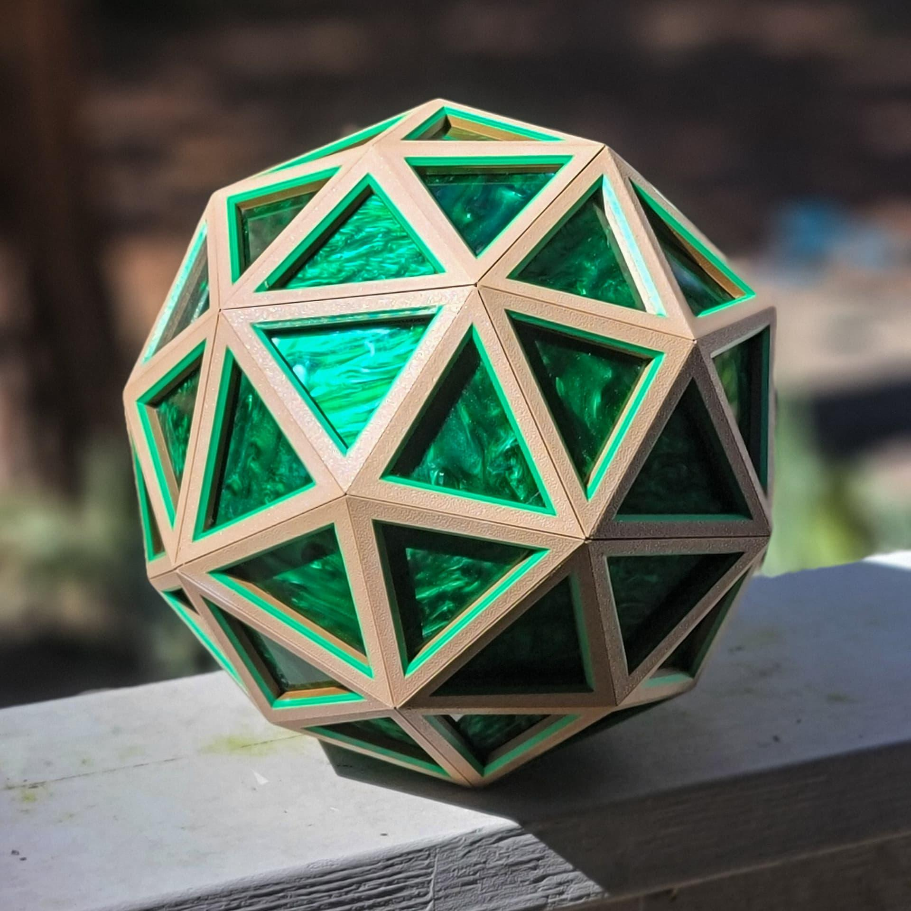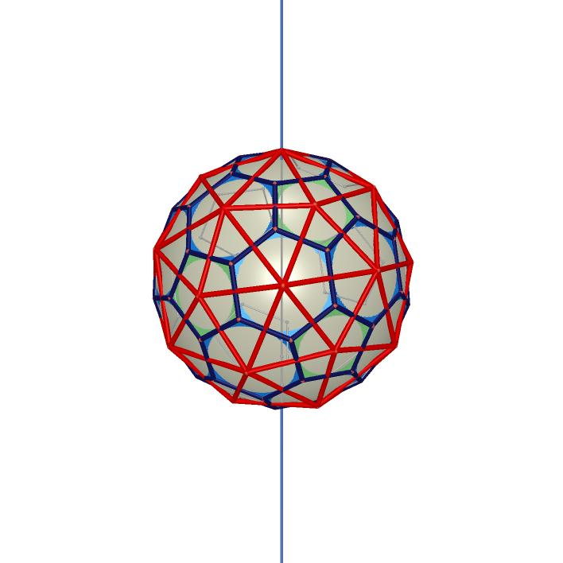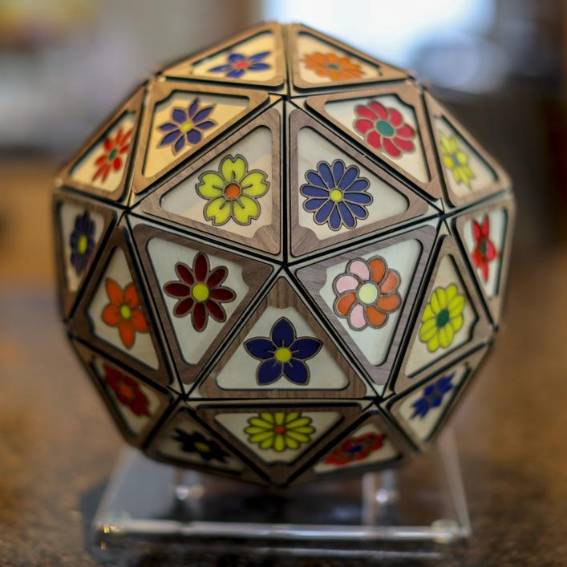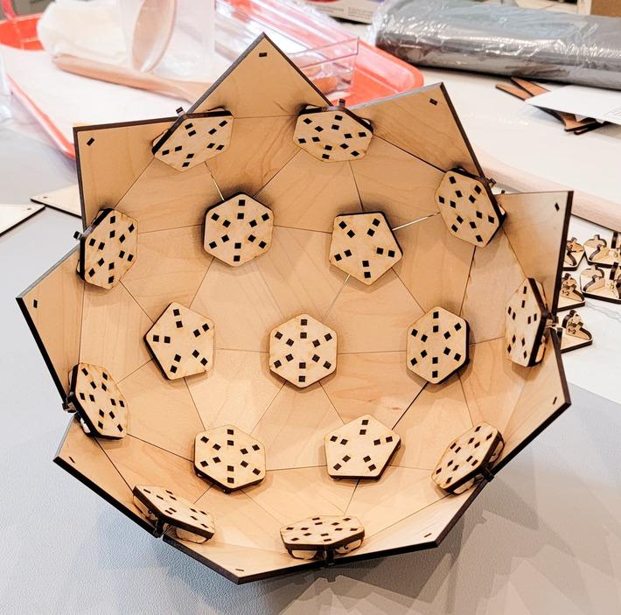
- Construct a regular dodecahedron: Draw and assemble 12 congruent regular pentagonal faces.
- Identify the pentagonal faces: Mark the center of each of the 12 faces.
- Determine the pyramid height: Establish the required height for the standard Catalan form. The height must be chosen so that all 60 resulting triangular faces are congruent.
- Construct the apex points: Mark one apex above the center of each pentagonal face.
- Connect the apex to the pentagon vertices: Draw five segments from each apex to the five vertices of its corresponding pentagon.
- Form the triangular faces: Each pentagonal face becomes five isosceles triangles.
- Repeat for all faces: Perform the same construction on all 12 pentagonal faces.
- Verify the structure: Confirm that the finished solid contains 60 triangular faces, 90 edges, and 32 vertices.
This construction is also called a kissoid or Kleetope construction: pyramids are attached to the faces of an existing polyhedron. The specified height produces the standard Pentakis Dodecahedron, rather than an arbitrary pentagonal-pyramid augmentation.

Method 3: Construction Through the Dual of a Truncated Icosahedron
# Source: AI Source: Provided by: [Data Path: Persons Table -> ID Column: 1, Name_En Column: Motasem Essam] -> From: [ChatGPT] on [7/25/2026]
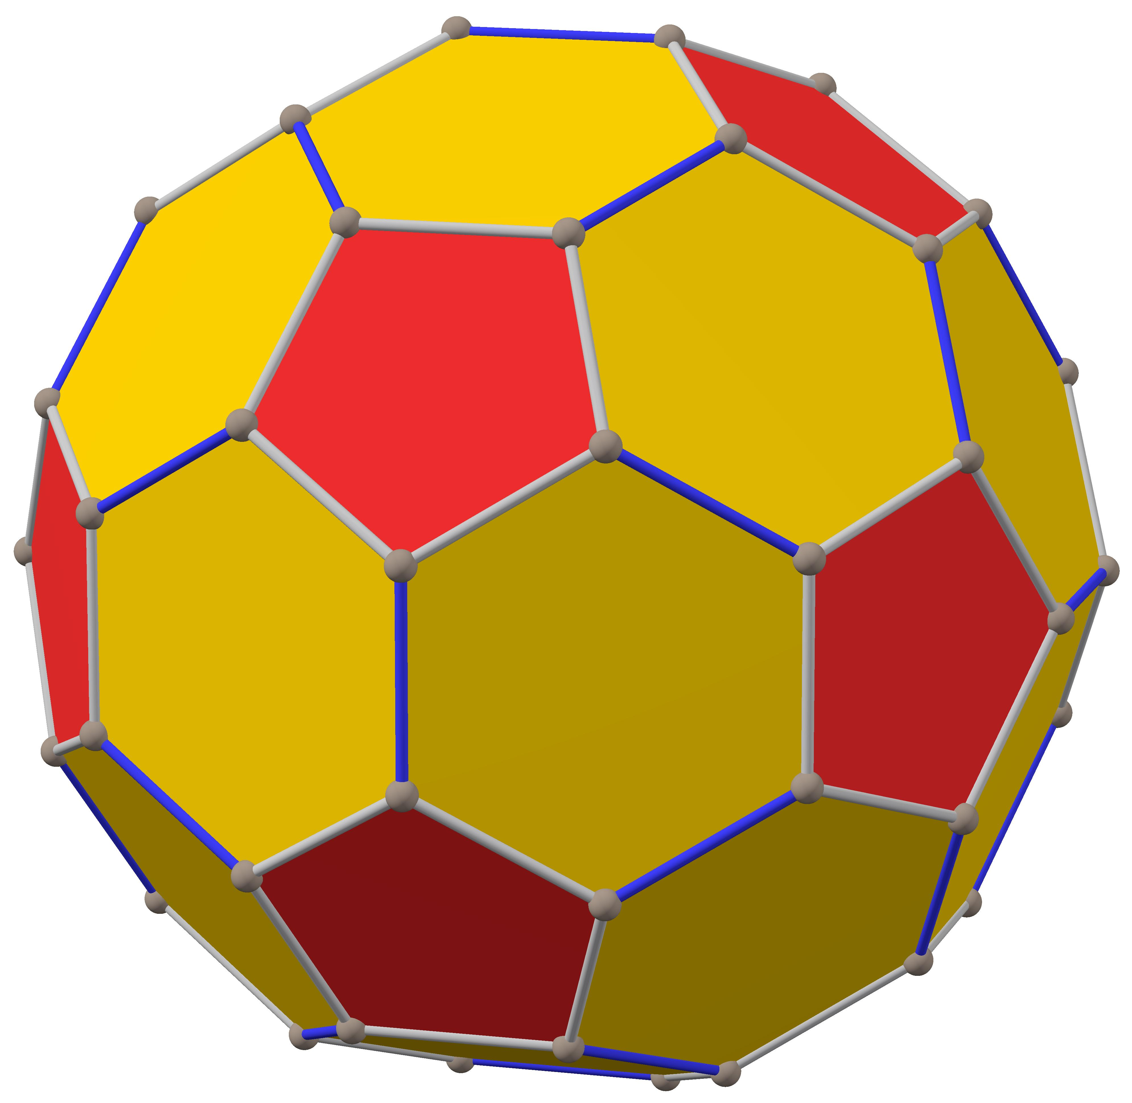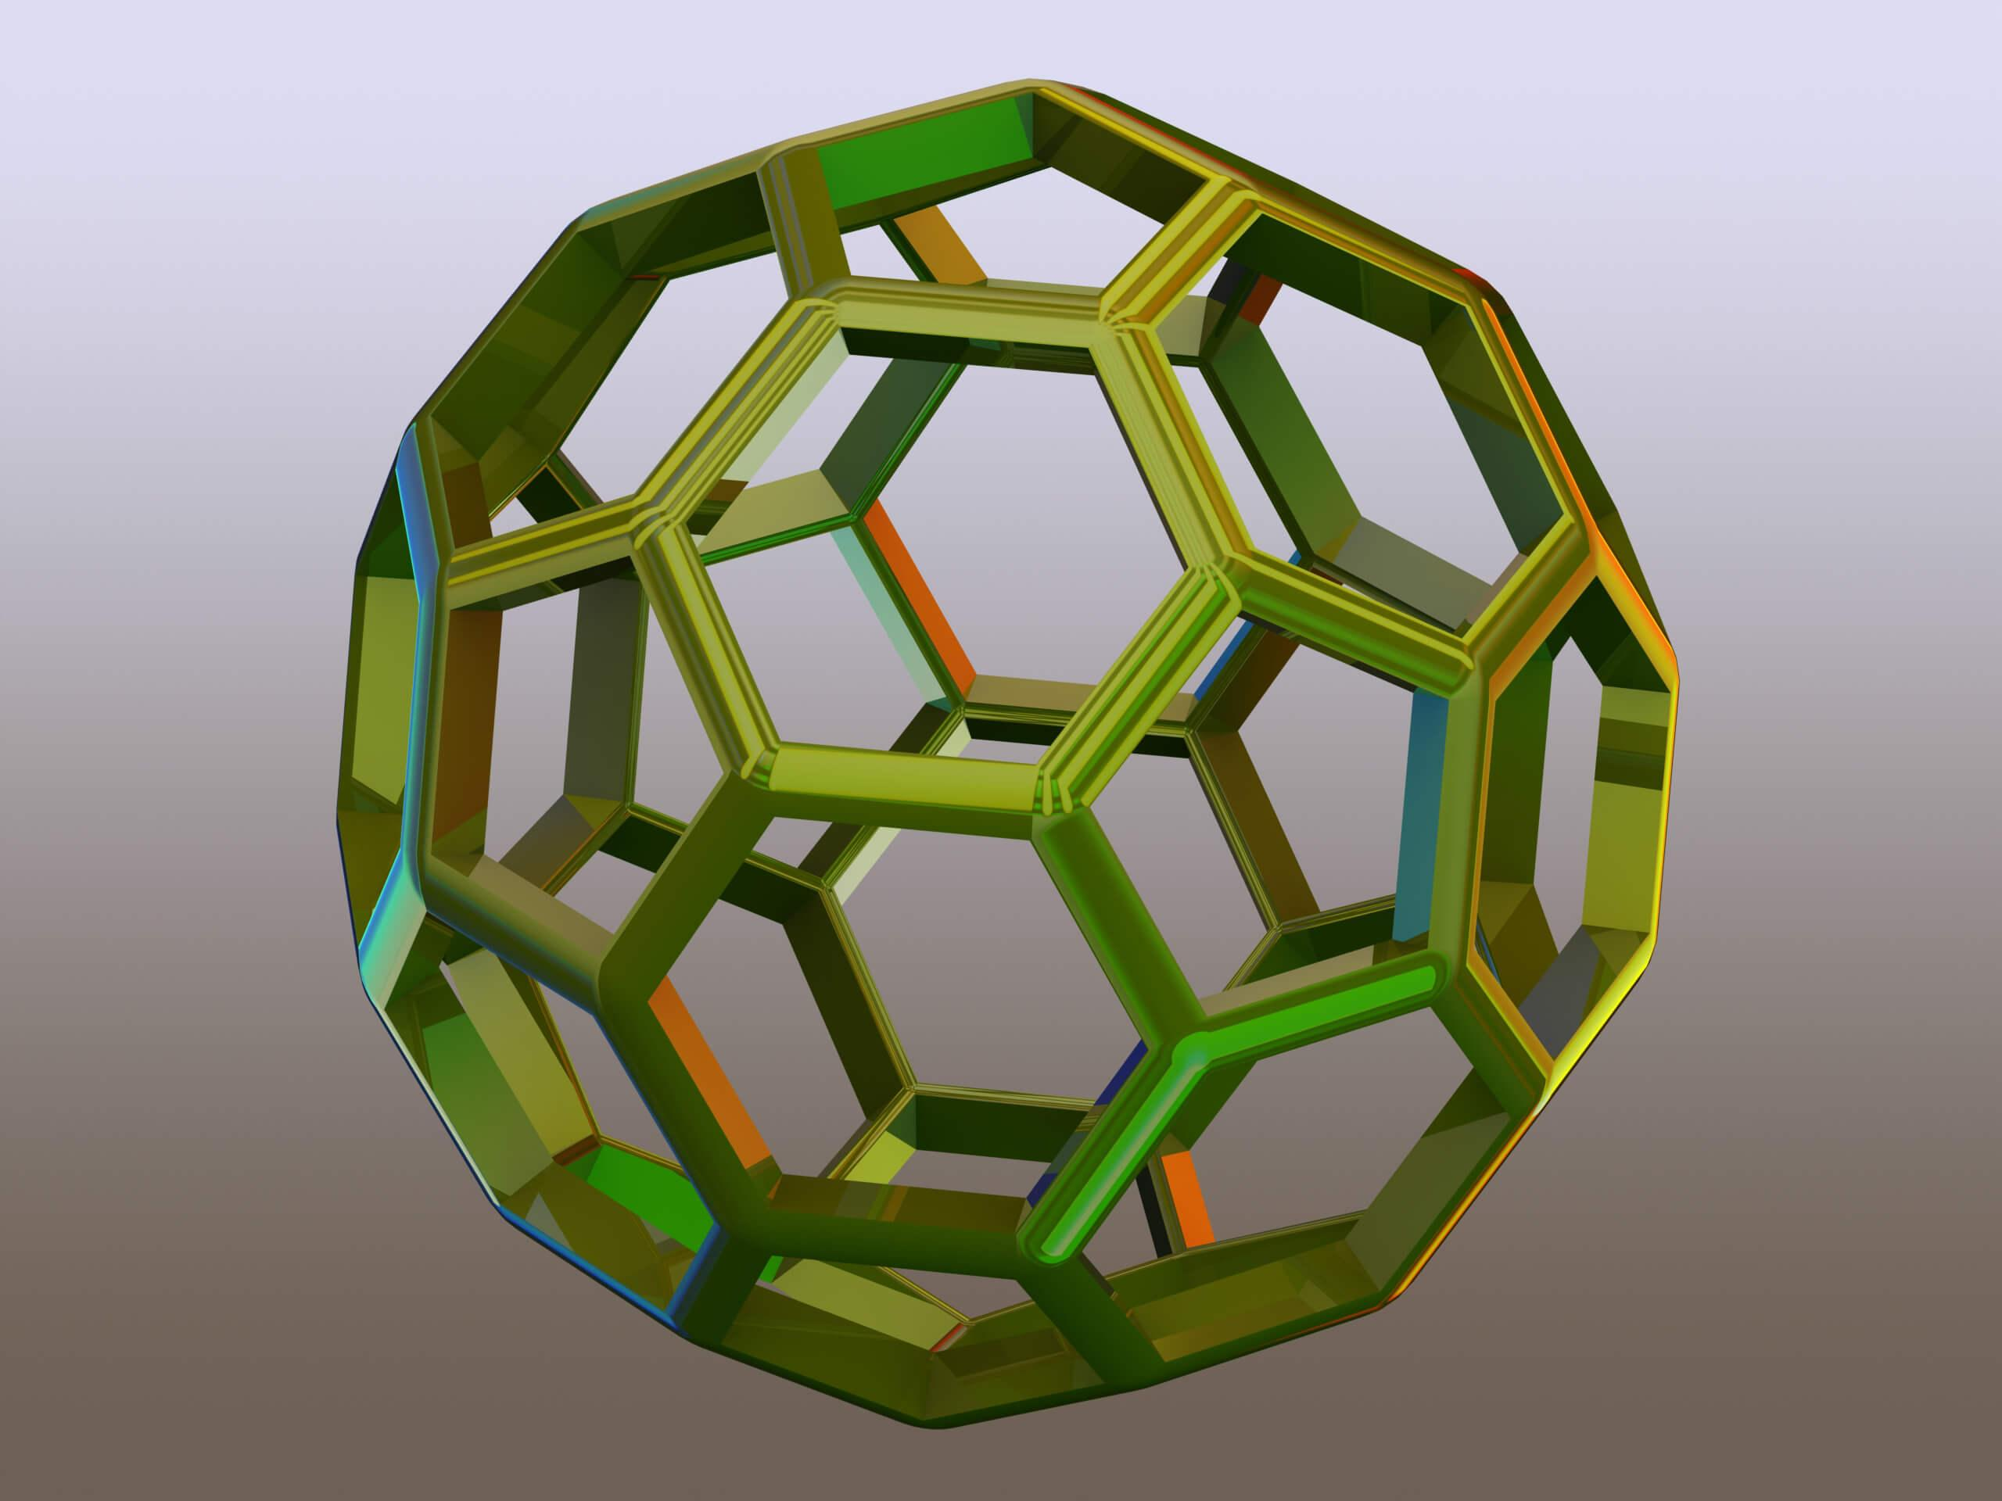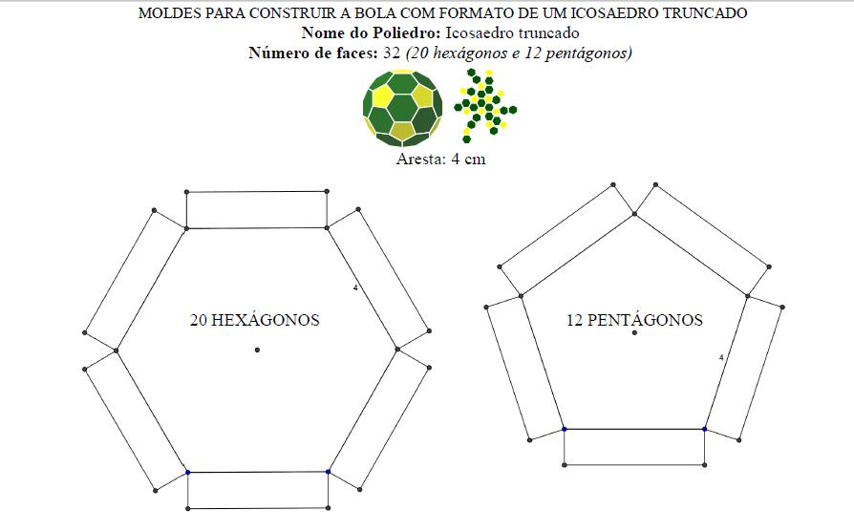
- Construct a truncated icosahedron: Use ruler-and-compass geometric constructions to establish its pentagonal and hexagonal faces.
- Identify its faces: Locate the centers and planes of its 12 pentagonal and 20 hexagonal faces.
- Establish the dual vertices: Construct one dual vertex corresponding to each original face.
- Determine the dual edge connections: Connect dual vertices associated with adjacent faces of the truncated icosahedron.
- Form the triangular faces: The three original faces surrounding each vertex determine one triangular face of the dual.
- Adjust the dual construction: Use the correct polar-dual scaling or reciprocal-plane construction to obtain the standard Catalan solid. Ordinary face centers alone do not necessarily produce the correct dual.
- Verify the completed solid: Check the 60 triangular faces, 90 edges, and 32 vertices.

Key Points
# Source: AI Source: Provided by: [Data Path: Persons Table -> ID Column: 1, Name_En Column: Motasem Essam] -> From: [ChatGPT] on [7/25/2026]
- The Pentakis Dodecahedron is one of the 13 Catalan solids.
- It has 60 congruent isosceles triangular faces.
- It has 90 edges and 32 vertices.
- It has two different edge lengths.
- It has 20 vertices where 6 edges meet and 12 vertices where 5 edges meet.
- It is the dual of the Truncated Icosahedron.
- It has full icosahedral symmetry $I_{h}$.
- It is a convex polyhedron.

Conclusion
# Source: AI Source: Provided by: [Data Path: Persons Table -> ID Column: 1, Name_En Column: Motasem Essam] -> From: [ChatGPT] on [7/25/2026]
The Pentakis Dodecahedron is a Catalan solid formed by the geometric arrangement of 60 congruent isosceles triangular faces. Its distinctive pointed structure, two types of vertices, and dual relationship with the Truncated Icosahedron make it an important example of polyhedral geometry.

References
# Source: AI Source: Provided by: [Data Path: Persons Table -> ID Column: 1, Name_En Column: Motasem Essam] -> From: [ChatGPT] on [7/25/2026]
- Wolfram MathWorld – Pentakis Dodecahedron.
- QFBox – The Pentakis Dodecahedron.
- MacTutor – Catalan Solids.
- Pentakis Dodecahedron – Geometric Properties.

